**UNIT 1**

* **Data Management in Enterprise systems**

Enterprise data management (EDM) is the process of inventorying and governing your business’s data and getting your organization on-board with the process. In other words, EDM is as much about managing people as it is about managing data. Data management means making sure your people have the accurate and timely data they need, and that they follow your standards for storing quality data in a standardized, secure, and governed place.

**Who’s in charge of enterprise data management and what do they do?**

Enterprise data managers are most often database administrators, IT administrators, or IT project managers. They are in charge of the process of managing your business’s entire data life cycle. They document and direct the flow of data from ingestion, and they control the process of removing data the business doesn’t need.

## Benefits of enterprise data management

By making data management a priority, you are ensuring that your data is in a secure place and available when your business users need it. This benefits your teams by enabling the following:

* Accessing high-quality data for accurate analysis
* Ensuring your data is secure and compliant under regulations
* Consolidating data across multiple sources for increased efficiency
* Having a consistent data architecture that scales with your enterprise
* **Workflow**

Workflow is the series of activities that are necessary to complete a task. Each step in a workflow has a specific step before it and a specific step after it, with the exception of the first and last steps. In a linear workflow, an outside event usually initiates the first step.

The three basic components of a workflow diagram are input, transformation, output. Every step within a workflow is assigned one of these statuses

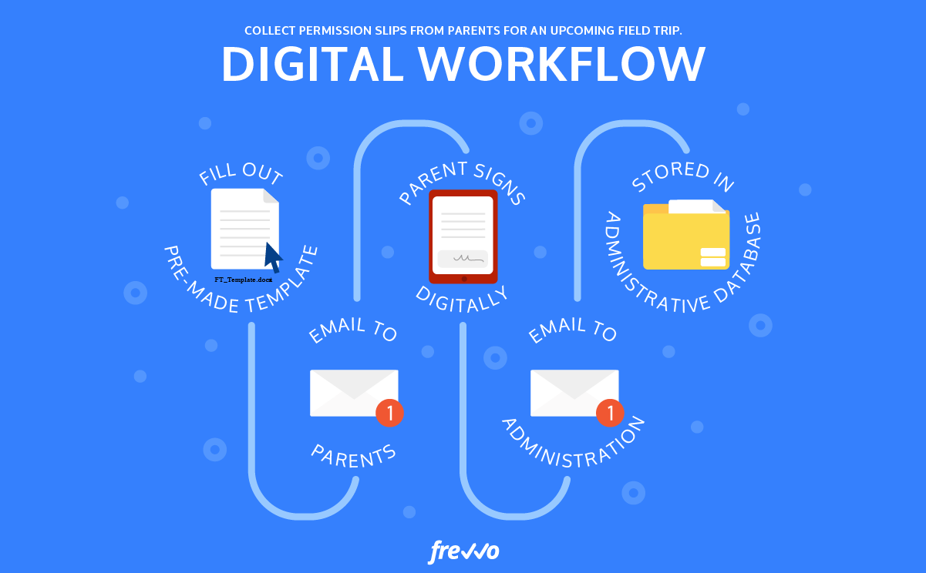

* **Controlling**

Enterprise control is the ability to combine control, intelligence and [process management](https://en.wikipedia.org/wiki/Business_process_management) to enable business optimization that is inclusive of business and production operations. It combines the strength of both business processes and production operations processes. It is the deliberate act of synchronizing [business strategy](https://en.wikipedia.org/wiki/Business_strategy) with operational execution in real-time to enable closed loop [business control](https://en.wikipedia.org/wiki/Business_control) across an enterprise.

* **Auditing**

An audit is a formal examination, inspection, and verification of a commercial enterprise's, organizations, or any entity's accounts. Audits are usually carried out by an independent party.

* **Accounting**

Enterprise accounting software comprises modules specific to billing and payroll, accounts receivable, accounts payable, general ledger, and more. Historically it has been a solution that was installed locally, but cloud-based solutions are increasingly available that tailor specific to enterprise business.

Some of enterprise accounting software’s main functions include:

* [Billing and invoice](https://flexi.com/wp-content/uploads/2017/08/FlexiBillPresentment.pdf)
* Budgeting and forecasting
* Fixed asset
* Payroll
* Inventory management

When shopping for an enterprise accounting software solution, there are many things to consider, including:

1. **Ease of use:** A user-friendly interface is paramount when you are switching to a new accounting system that you want your employees to adopt.
2. **Security:** Backups, encryption, and user-specific permissions are important, especially for cloud-based enterprise accounting software solutions.
3. **Mobile access:** The cloud affords access to any device with an internet connection, which is ideal for most of today’s business scenarios where employees are remote, traveling, or inclement weather keeps them home.
4. **Customization:**Each organization has different needs, so choosing a solution that will give you some wiggle room to specifically tailor your software to your unique needs is extremely important.
5. **Integrated modules:** Integration is of the utmost important, even if the modules happen to be sold separately. A unified platform will make your business run smoothly.

* **Enterprise resource planning** (ERP)

Enterprise resource planning (ERP) refers to a type of software that organizations use to manage day-to-day business activities such as accounting, procurement, project management, risk management and compliance, and supply chain operations.

* **Supply Chain Management (SCM)**
* Supply chain management (SCM) is the centralized management of the flow of goods and services and includes all processes that transform raw materials into final products.
* By managing the supply chain, companies can cut excess costs and deliver products to the consumer faster and more efficiently.
* Good supply chain management keeps companies out of the headlines and away from expensive recalls and lawsuits.
* The five most critical elements of SCM are developing a strategy, sourcing raw materials, production, distribution, and returns.
* A supply chain manager is tasked with controlling and reducing costs and avoiding supply shortages

* **Customer relationship management (CRM)**

Customer relationship management is a process in which a business or other organization administers its interactions with customers, typically using data analysis to study large amounts of information.

The three types of CRM systems are **operational, analytical and collaborative**.

* **Product Life Cycle (PLC)**

The process of its implementation to automate business processes is referred to as ERP implementation life cycle. It involves several steps and stages right from the start, planning for project implementation, analysis, design, implementation, transition, and operations.

* **Human Resource Management (HRM)**

Human resource management is the strategic and coherent approach to the effective and efficient management of people in a company or organization such that they help their business gain a competitive advantage. It is designed to maximize employee performance in service of an employer's strategic objectives.

* **General Ledger (GL) System**

A general ledger (GL) system aggregates financial transactions across multiple business entities in real time, structures and reconciles them, and provides data to generate consolidated financial reports.

**6 common types of general ledger accounts**

* Assets.
* Liabilities.
* Equity.
* Revenue.
* Expenses.
* Other income accounts.

What is GL in ERP?

The General Ledger (GL) is the primary accounting record for a business. It tracks all financial transactions and is used to generate the company's financial statements, including the Income Statement and Balance Sheet.

